**DEPLOYING AN STATIC WEBSITE ON AWS S3**

**Overview:**

To host a static website by deploying a sample website using amazon S3. We can also include versioning, custom domain setup and SSL certificate integration for added sophistication.

1. Select S3 from AWS services.

Buckets > Create bucket

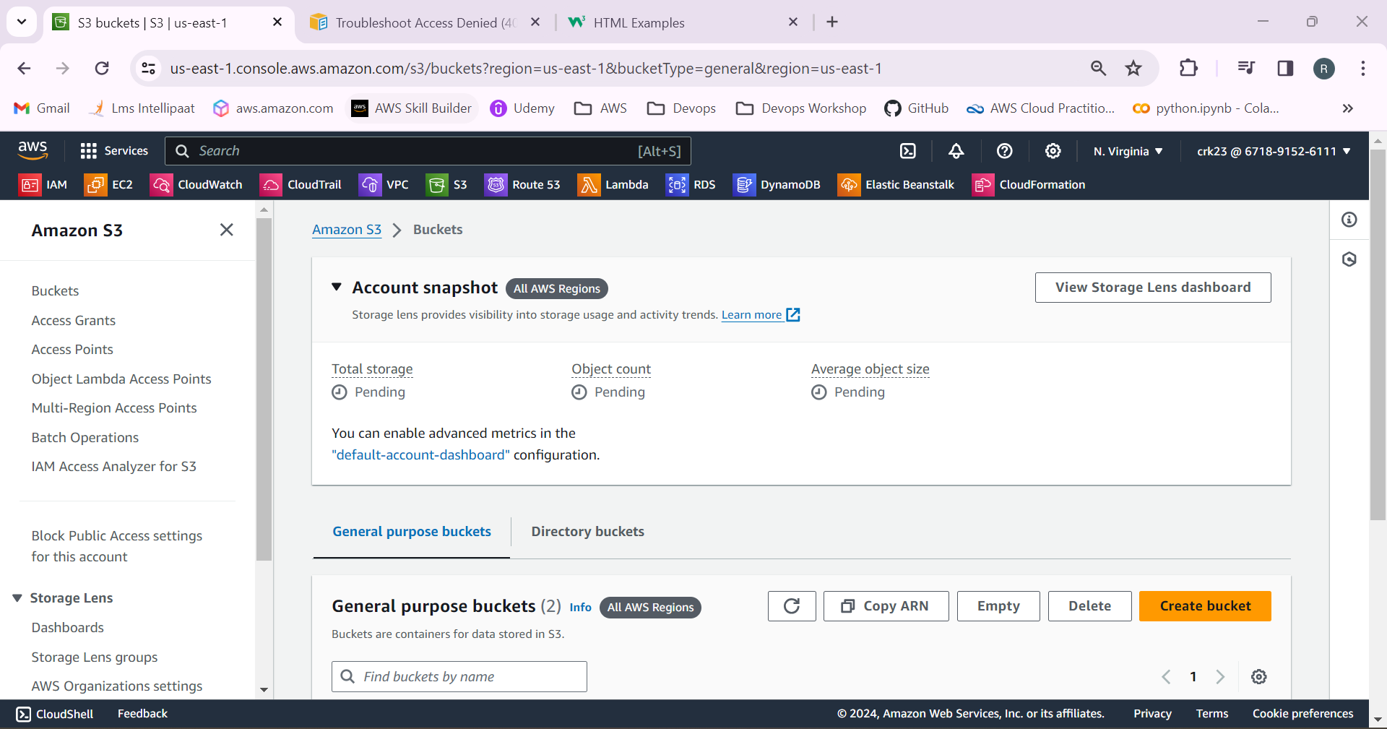

2.Select general purpose and bucket name should be globally unique name.

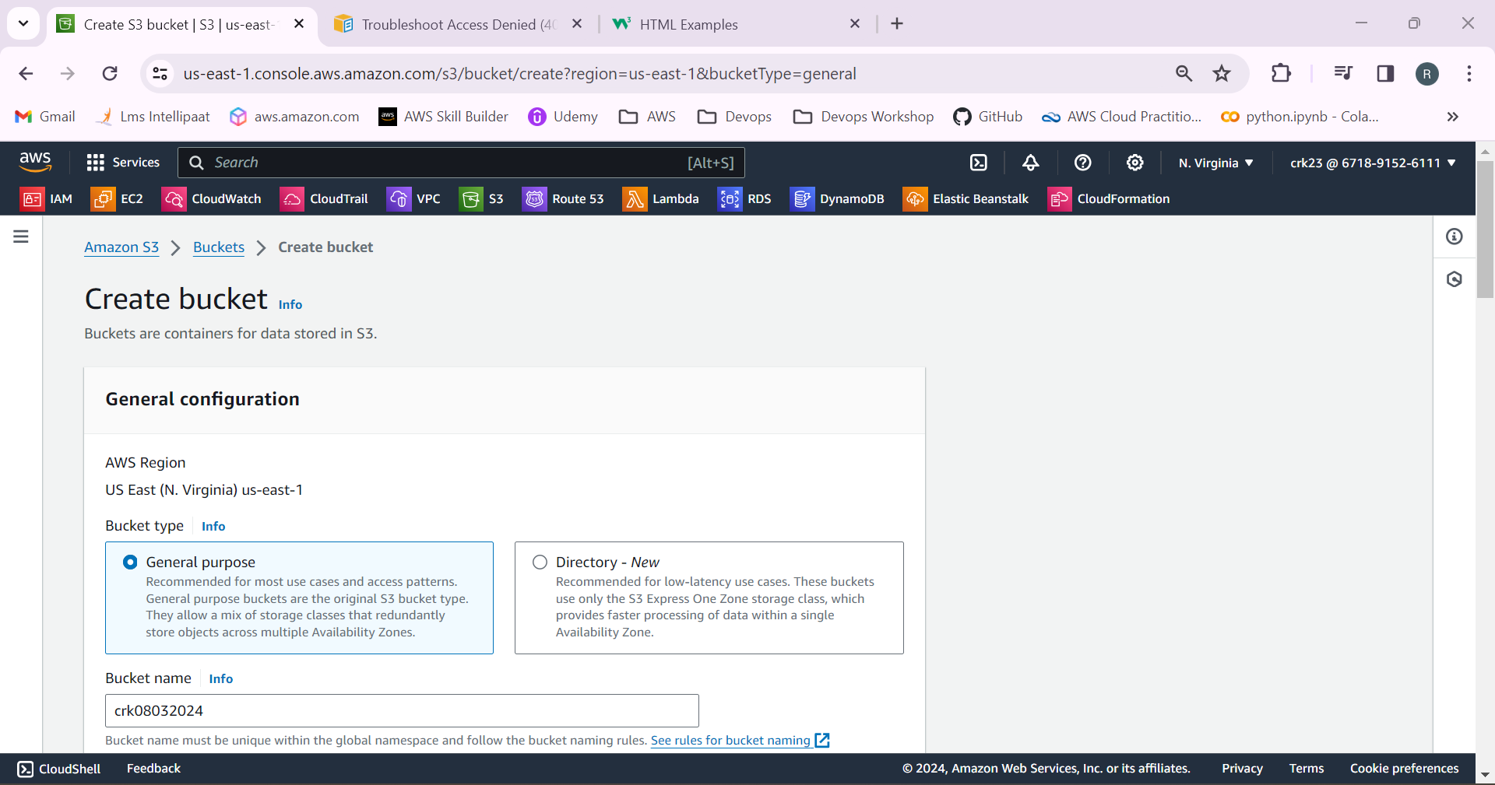

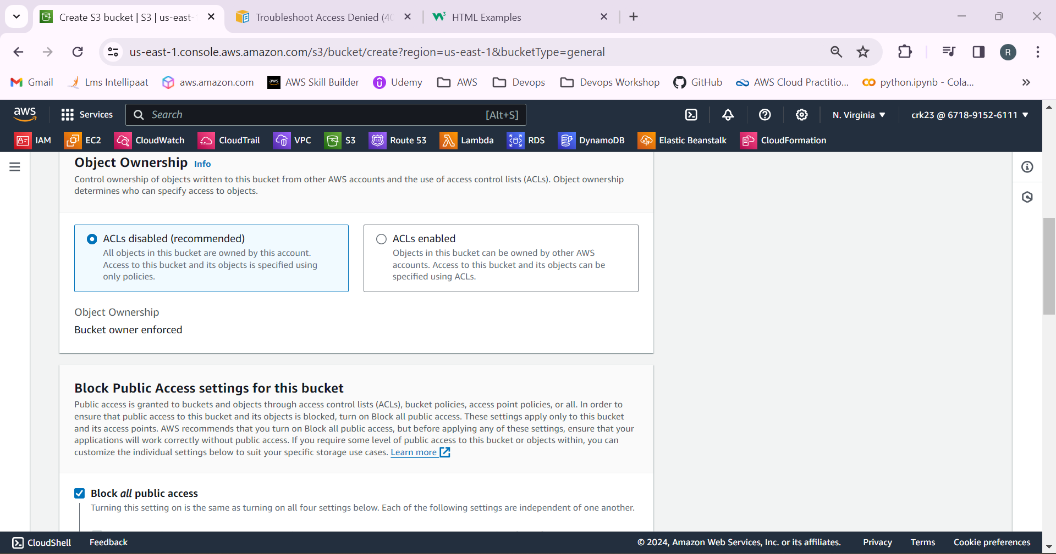

3.Bucket versioning is enabled.

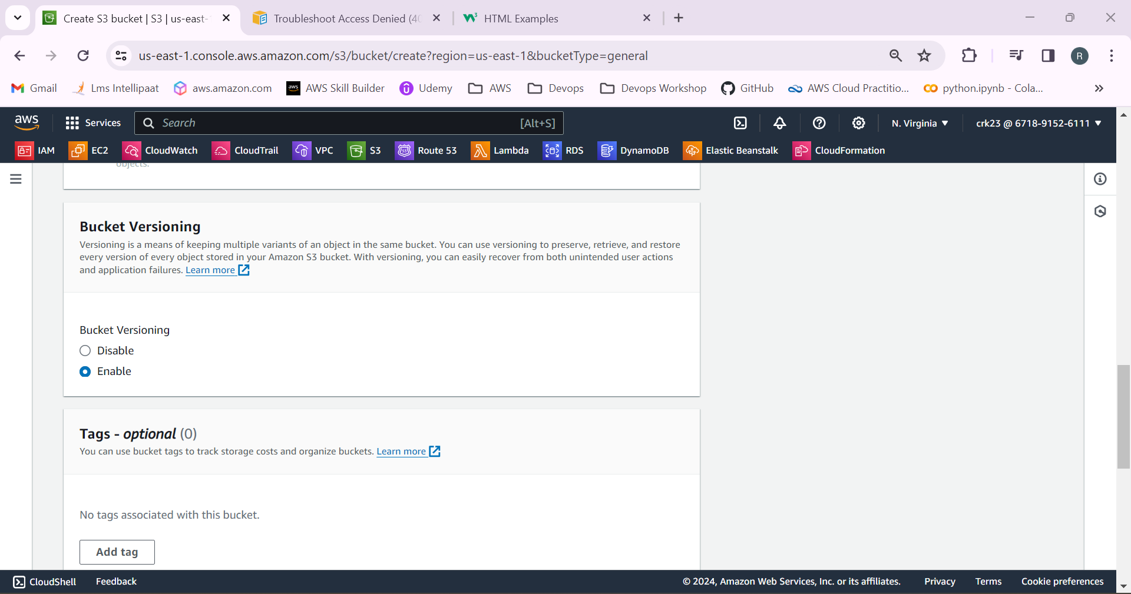

4.S3 Bucket has been created.

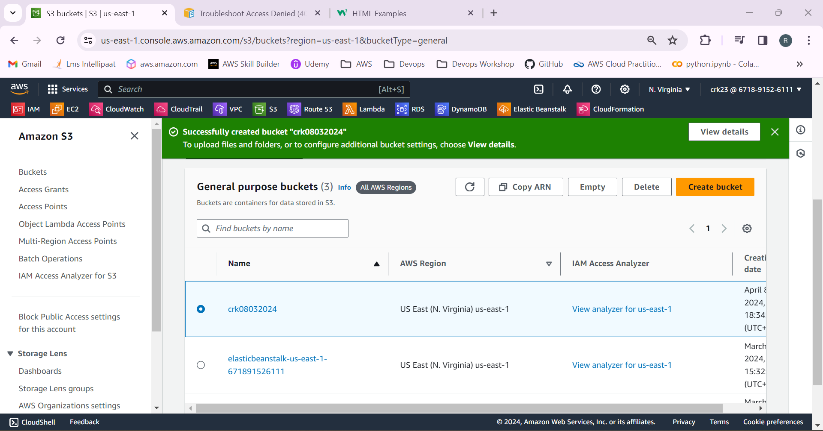

5.Select the bucket and upload a index.html file in it.

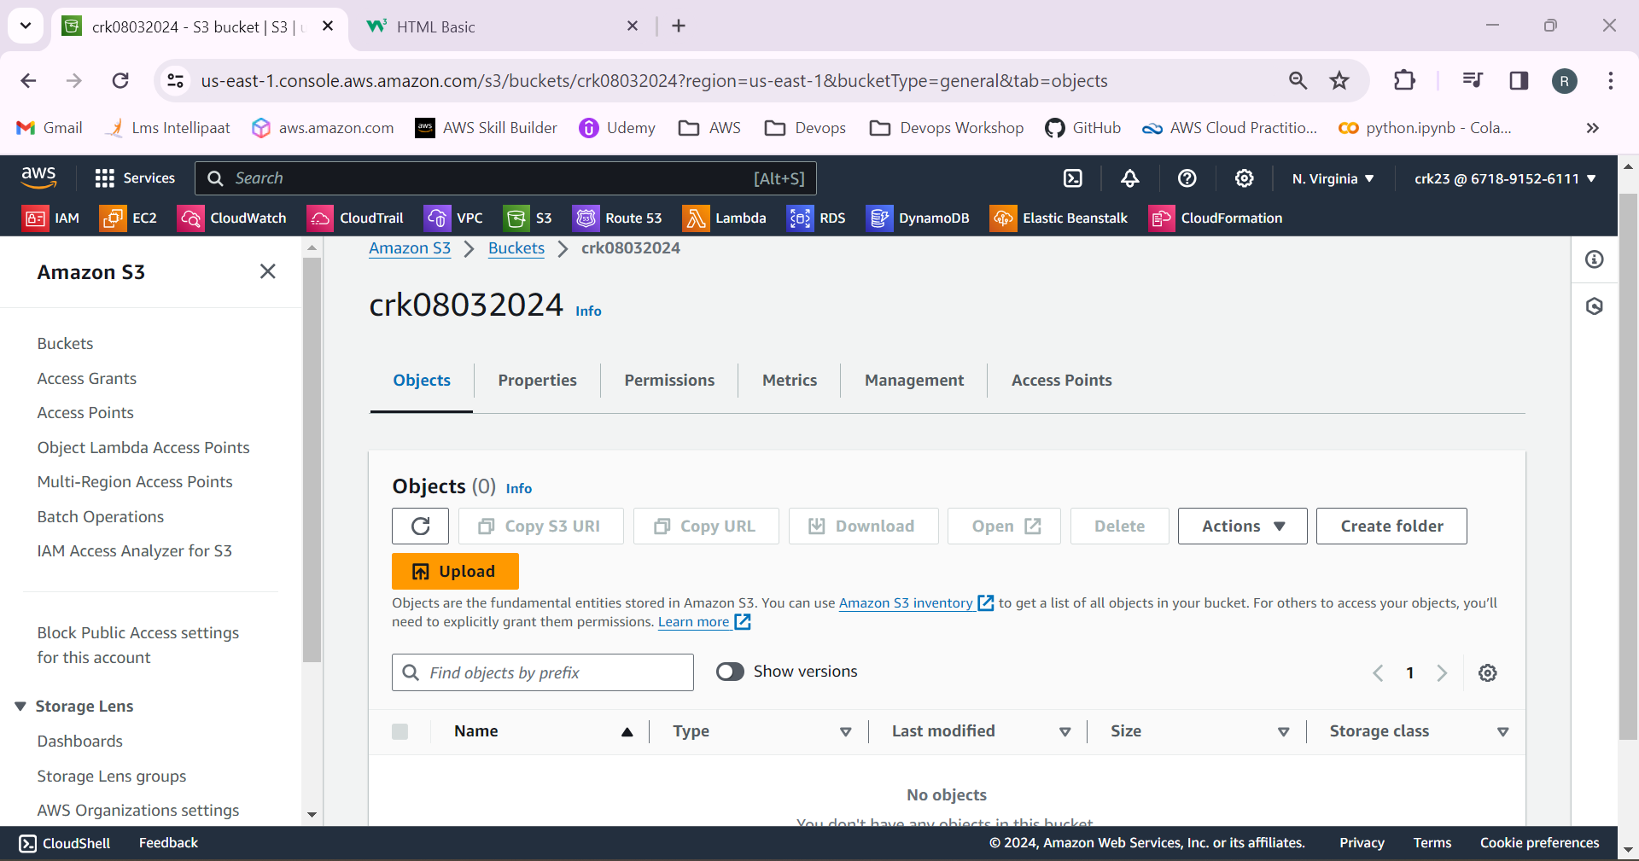

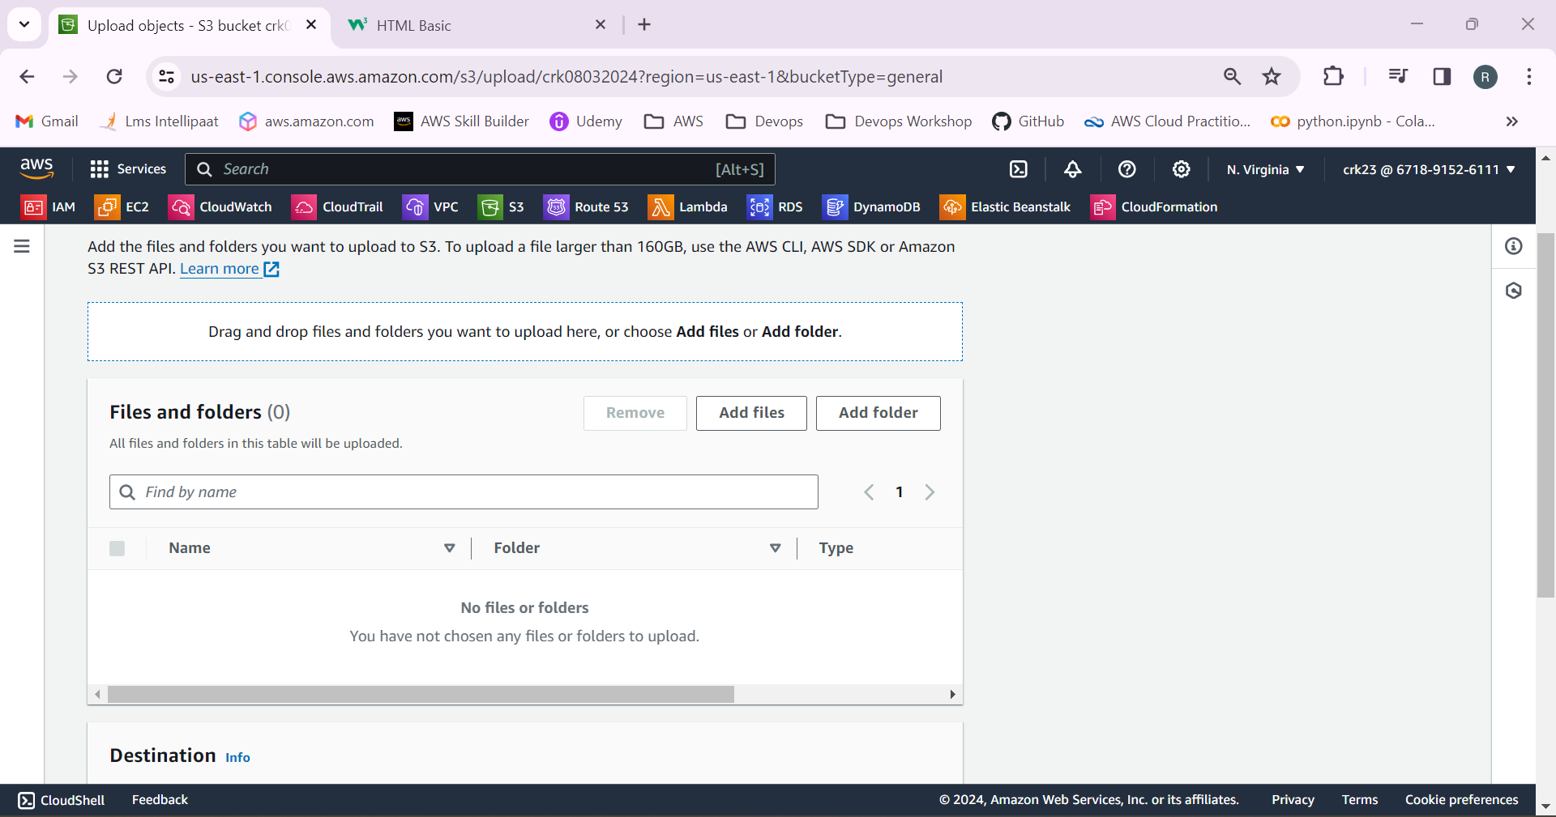

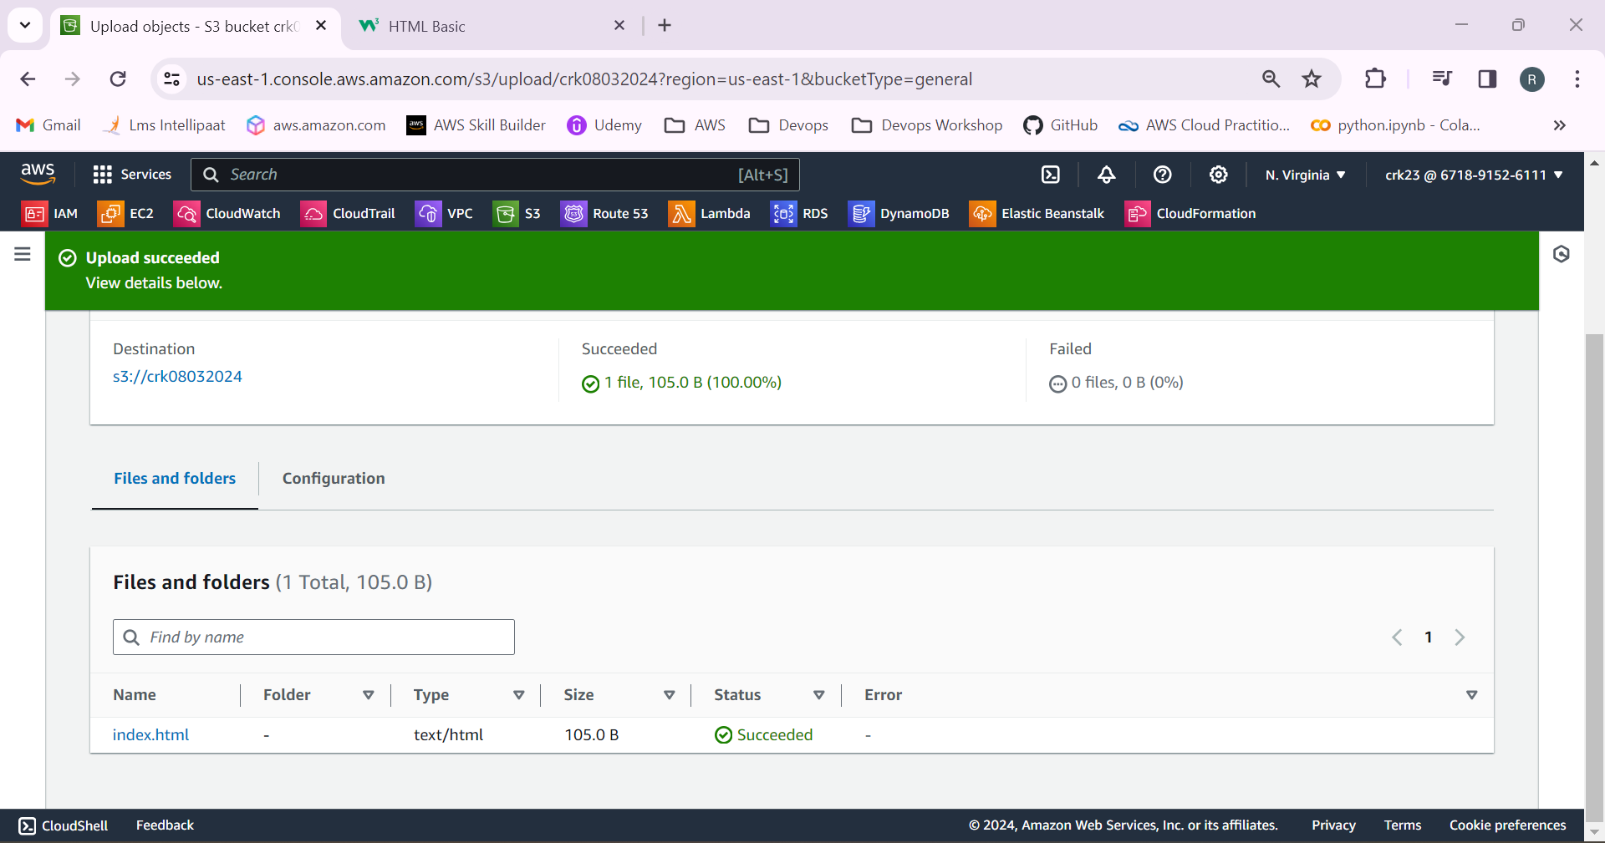

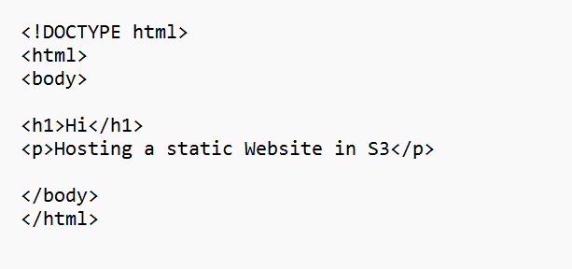

6.Select properties > Static website hosting

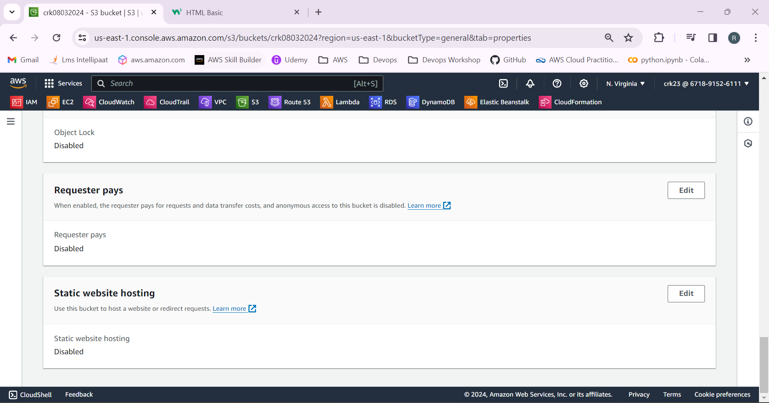

Enable it!

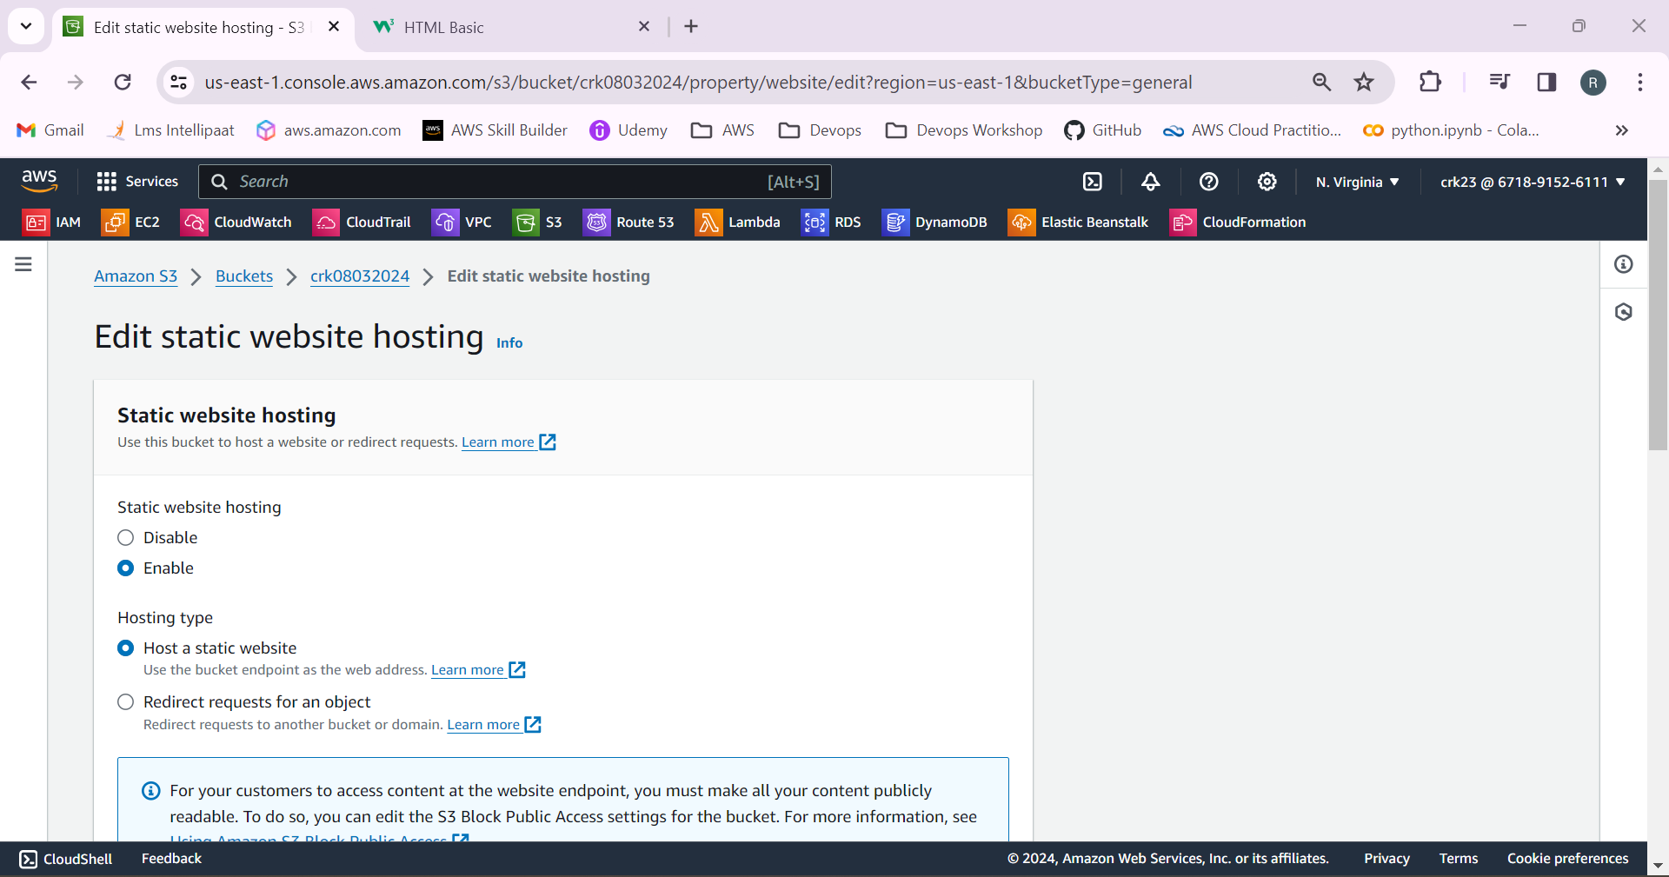

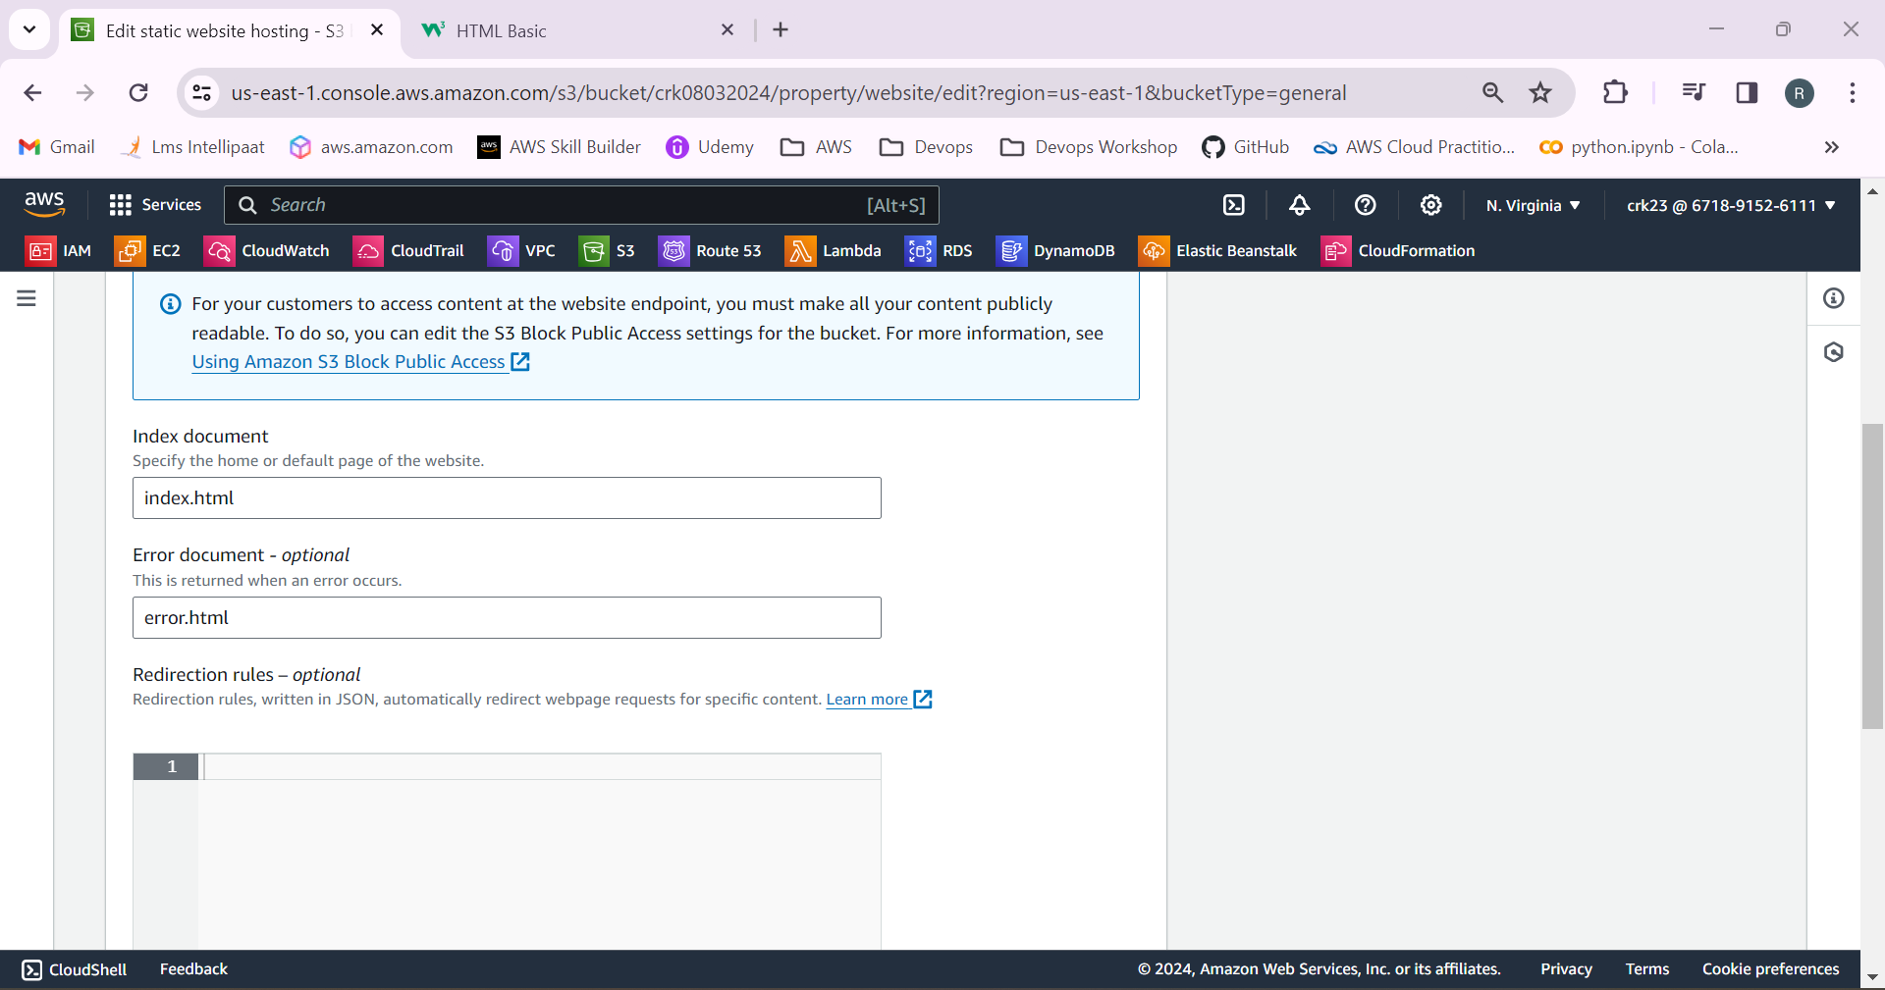

URL will be generated after hosting has been enabled.

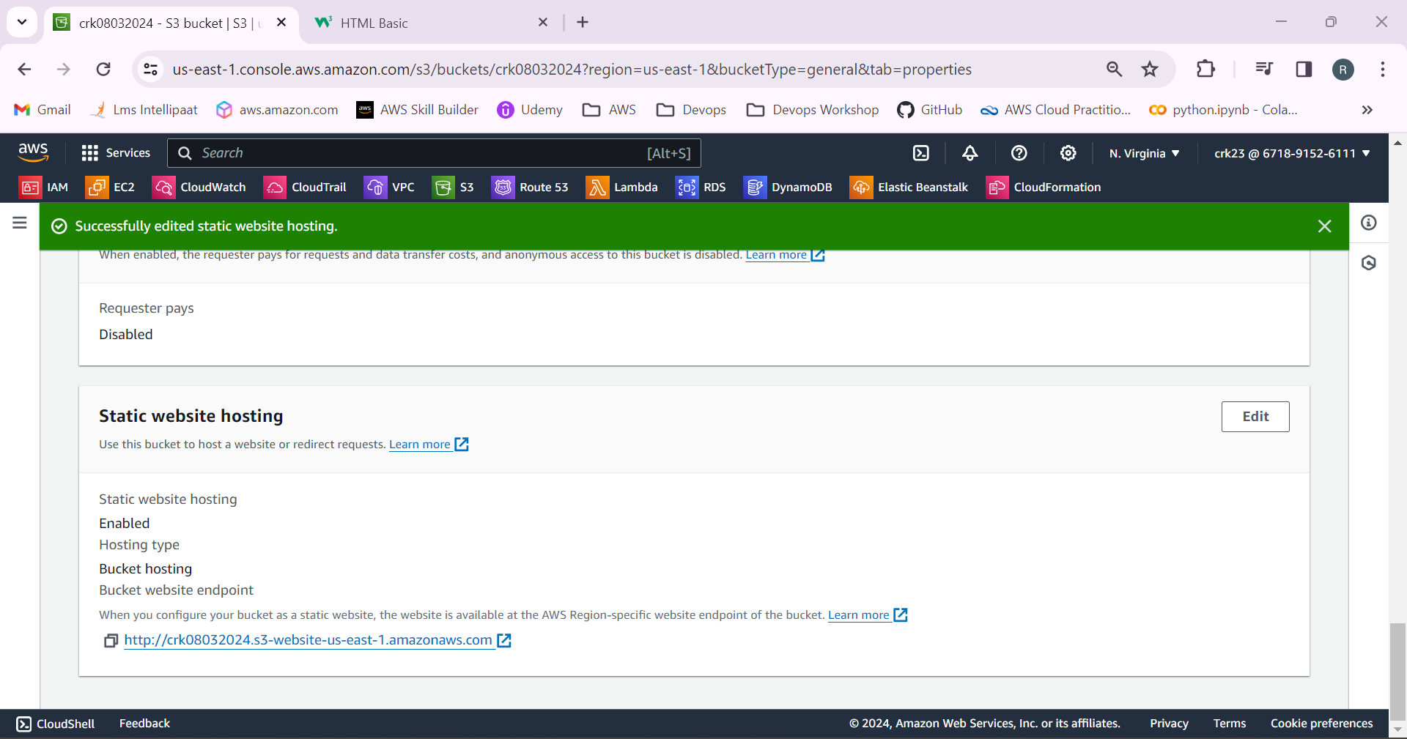

7.Disable the Block all public access to access the website from the website.

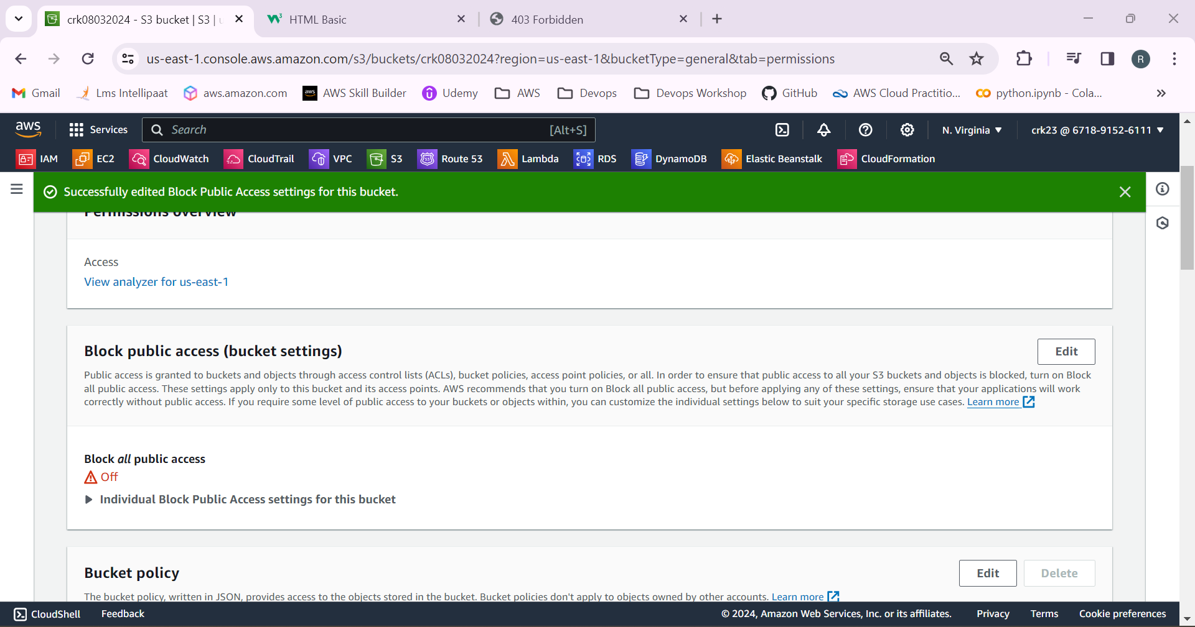

8.If we try to access the website now we cannot access the website.

By default, the objects in the bucket are still private, meaning they can only be accessed by users who have appropriate permissions. If you want to make your website publicly accessible, you need to adjust the permissions by using bucket policy.

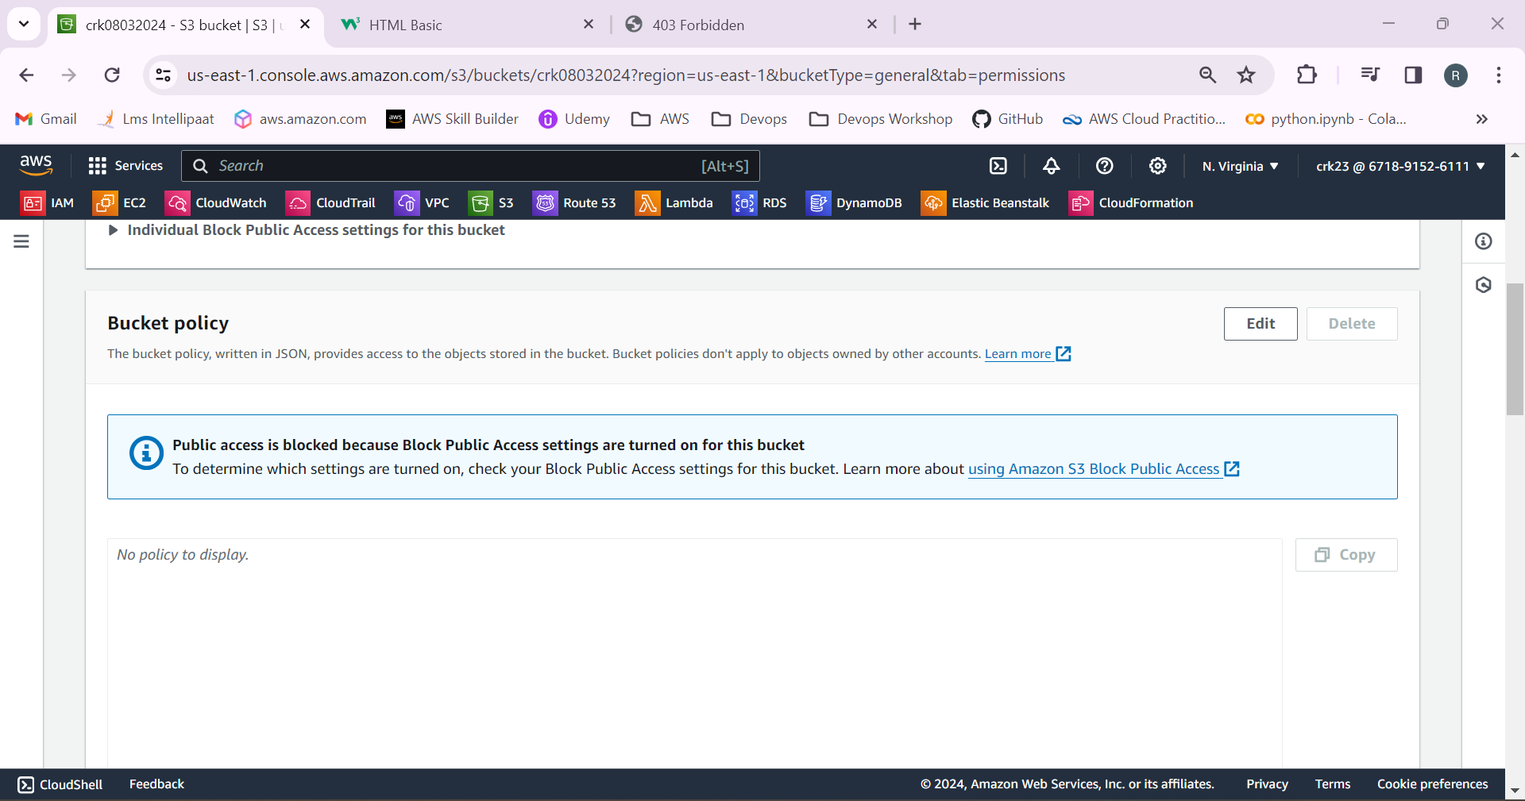

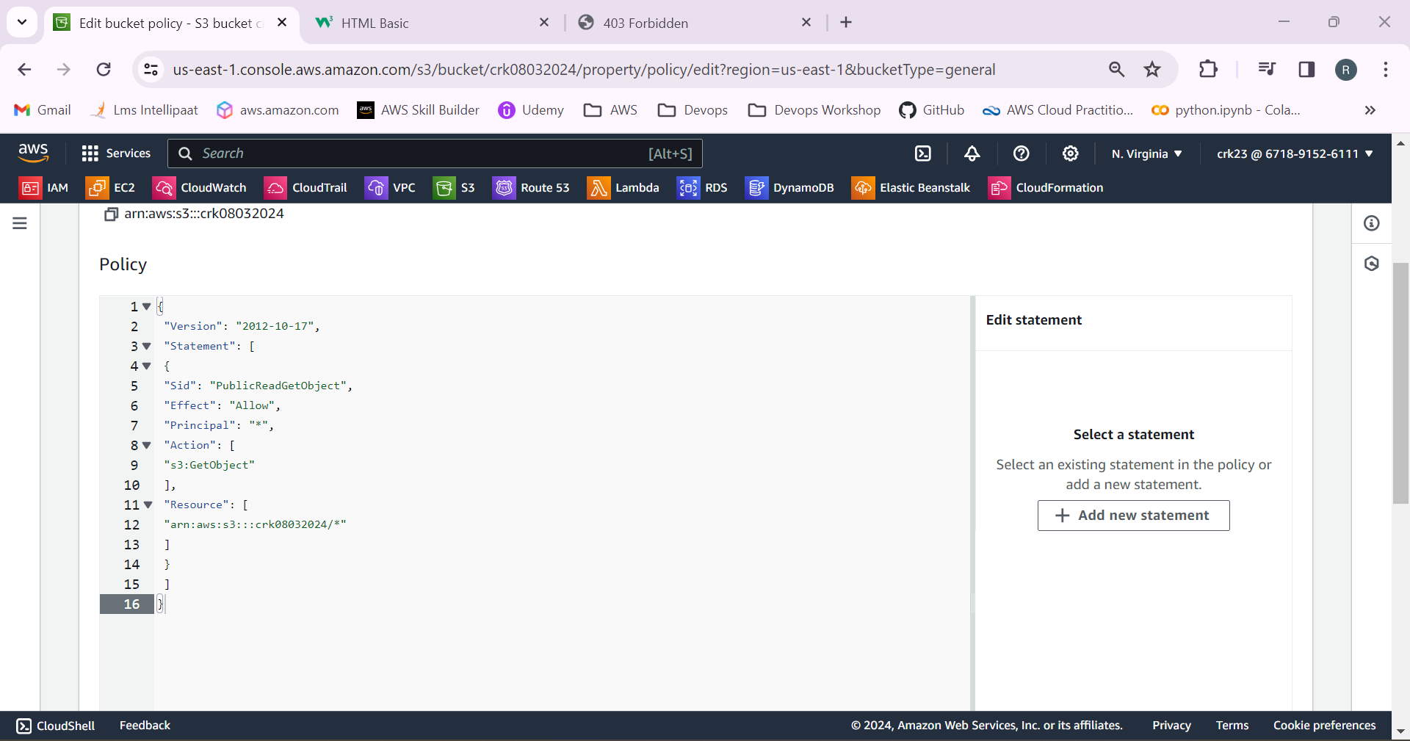

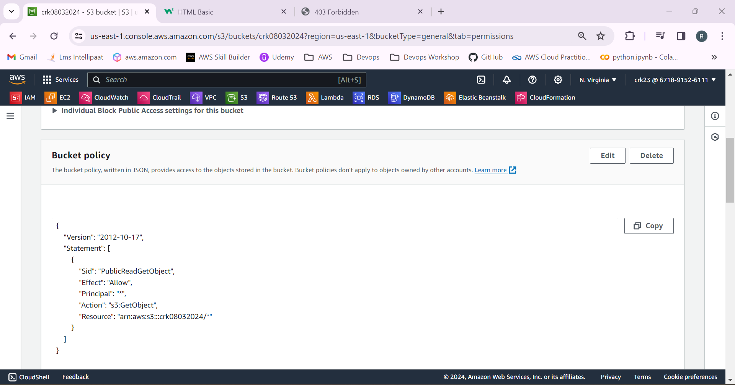

9.Now access the website using the URL.

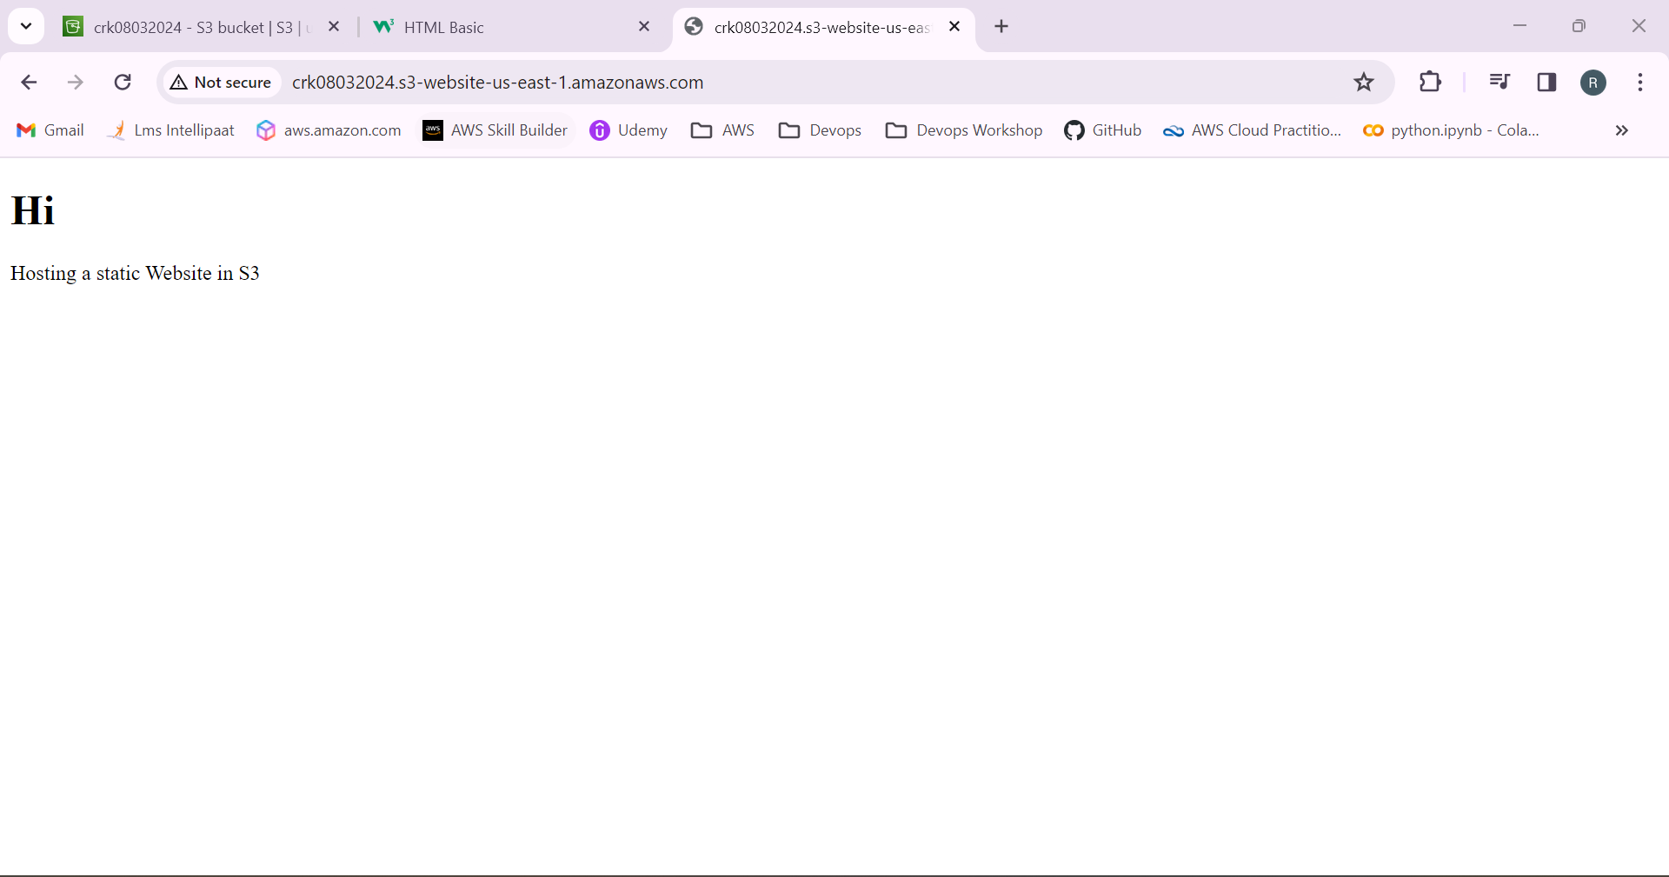

It works!